k
University of Glasgow
School of Engineering

Power Engineering 3 ENG3041

Lab 2: Single Phase Transformer Laboratory

Version 4

Student Name: Daniel Borkovec

Matric No: 2941124B

Introduction

Transformers are one of the principle reasons why we have AC Power Networks as opposed to DC systems. Their ability to provide a (relatively!) cheap and reliable means of converting AC voltage levels results in high efficiency AC power transmission. In this series of experiments you will investigate the main features of a small single phase transformer, and by the end of the laboratory you should have a good understanding of the following:

- The Ideal Transformer equations
- The equivalent circuit for a practical single phase transformer
- The Open Circuit & Short Circuit Tests to determine equivalent circuit parameters
- Using the equivalent circuit to predict transformer performance
- Transformer Voltage Regulation & Efficiency under load
- The Transformer Voltage and Current Limits

Assessment

The 3 laboratory sessions account for 10% of your final mark in Power Engineering 3. You should have with you a bound laboratory book (with graph paper). Record ALL your measured results and any subsequent calculations in your bound laboratory book during the laboratory session, also fill out the necessary results in this lab sheet (this makes it easy for me to check your results during the session).

At some point after the lab session you need to write up the results (neatly!) and complete the associated analysis/theory sections before handing in your lab books before the end of the semester.

Note that you will not be assessed during the laboratory session so please communicate freely with supervisor/demonstrators – we are here to help you obtain accurate results and to help with any questions you have relating to the associated theory.

Experiment 1: Determining the Transformer Turns Ratio

The equivalent circuit for an Ideal Transformer is shown on figure 1 where N_{P} is the number of turns on the primary winding and N_{S} is the number of turns on the secondary. The corresponding relationships between primary and secondary voltages and currents are as follows:

N_{P}/N_{S} is termed the Turns Ratio

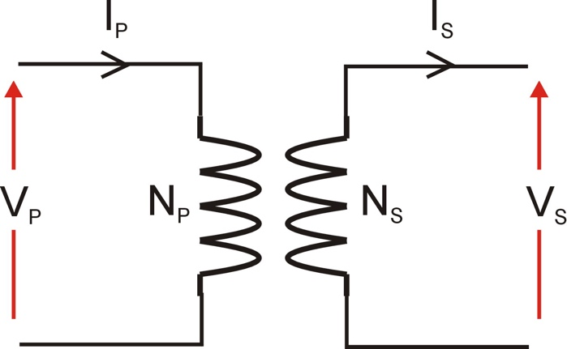

Figure 1: The Ideal Transformer

Clearly the Turns Ratio is very important in defining the operation of a transformer (note: it is used in the equivalent circuit for the practical transformer as well!) and in this first experiment we will determine this turns ratio from measurement:

The experimental setup for this experiment is shown on figure 2. The Turns Ratio can be calculated by measuring the Open Circuit Secondary Voltage (V_{SOC}) at a given Primary Voltage (V_{P}) and then using the voltage ratio (V_{P}/V_{SOC}) to calculate the turns ratio.

Experimental Procedure:

- Set the AC power supply voltage to zero (Voltage Adjust should be turned fully counter-clockwise until it hits the end-stop).
- Turn on the AC power supply.
- Connect the Power Meter to the Primary circuit monitoring point (PM) on the transformer.
- Adjust AC power supply voltage (using Voltage Adjust) until approximately 30V is displayed on the Power Meter.
- Record the transformer Primary voltage (V_{P}) displayed on the Power Meter.
- Connect the Power Meter to the Secondary circuit monitoring point (SM) on the transformer.
- Record the transformer Open Circuit Secondary voltage (V_{SOC}) displayed on the Power Meter.
- Adjust the AC power supply voltage to zero.
- Turn off the AC power supply.

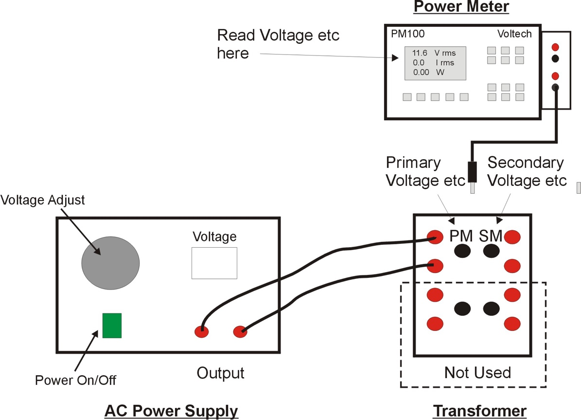

Figure 2: Experiment 1 Setup

Using the measured values of primary and secondary voltages, and the Ideal Transformer voltage equation shown above determine the transformer Turns Ratio:

Measured Parameter | Value | Units
Primary Voltage (V_{P}) | 30.18 | V
Secondary Voltage (V_{SOC}) | 11.23 | V

Calculated Parameter | Value | Units
Turns Ratio | 30.18/11.23 =  2.69 | Unitless

Experiment 2: Determining the practical Transformer Equivalent Circuit

As will be outlined in the lectures the practical transformer has an equivalent circuit which takes into account issues such as wiring copper loss, leakage inductance, magnetising current and iron loss. The complete equivalent circuit for a transformer is shown on figure 3.

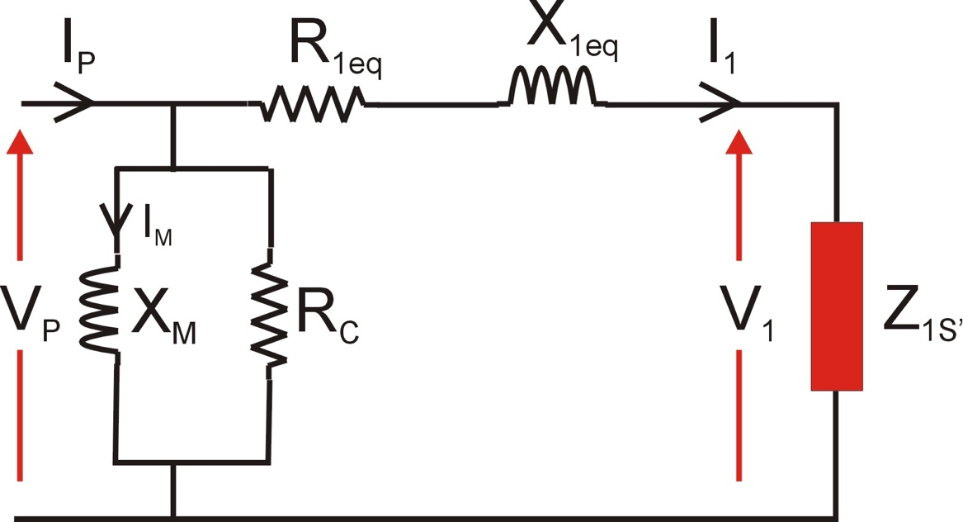

Figure 3: Transformer Equivalent Circuit

The purpose of the next couple of tests is to determine values for the transformer parameters R_{1eq}, X_{1eq}, X_{M} and R_{C}

Experiment 2A: Open Circuit Test (to determine X_{M} and R_{C})

In this experiment the secondary winding is open circuit (Z_{1S’} is Open Circuit) and therefore I₁ = 0A and the equivalent circuit simplifies to that shown on figure 4.

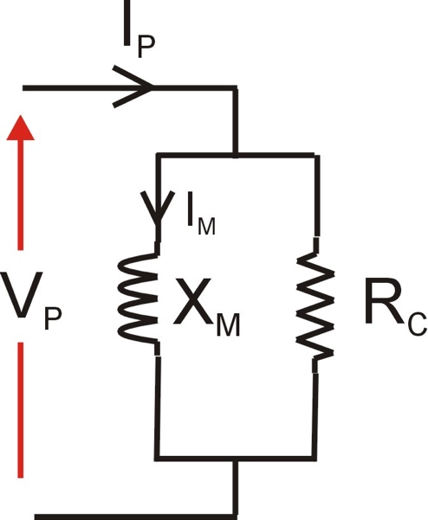

Figure 4: Open Circuit Test Equivalent Circuit

Notice that we have one resistive component R_{C} and one inductive component X_{M}. By knowing (hopefully!) that REAL Power is associated with the resistance and REACTIVE power is associated with inductance we can determine each of these components by simply measuring primary voltage (V_{P}), primary current (I_{P}) and primary real power (W) and using the following primary circuit relationships:

Parameter | Units | Equation
Real Power | W
Apparent Power | VA
Reactive Power | VAr
Reactive Power | VAr

Repeat the test outlined in Experiment 1 but this time record primary voltage (V_{P}), primary current (I_{P}) and primary real power (P_{P}). From test results and above equations determine values for R_{C} and X_{M}:

Measured Parameter | Value | Units
Primary Voltage (V_{P}) | 30.21 | V
Primary Current (I_{P}) | 0.101 | A
Primary Real Power (P_{P}) | 0.859 | W

Note: the Power Meter current and power values may be in milliamps and milliwatts

Calculated Parameter | Value | Units
Primary Apparent Power (S_{P}) | 3.05 | W
Primary Reactive Power (Q_{P}) | 2.93 | W
Magnetising Reactance (X_{M}) | 311 | Ω
Iron Loss resistance (R_{C}) | 1062 | Ω
Experiment 2B: Short Circuit Test (to determine R_{1eq} and X_{1eq})

In this experiment (see next page for setup) the secondary winding is short circuit (Z_{1s’} = 0Ω) and as a result I₁ current will flow in the primary. Under short circuit conditions I₁ is very much bigger than magnetising and iron loss currents and so these elements can be ignored and the equivalent circuit simplifies to that shown on figure 5.

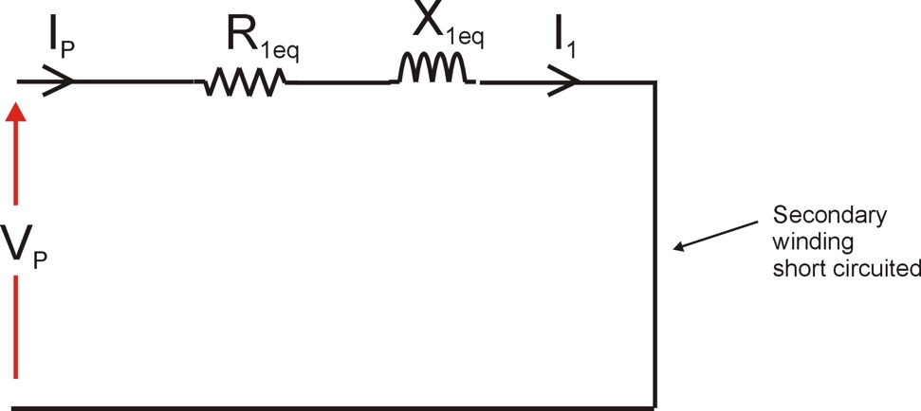

Figure 5: Short Circuit Test Equivalent Circuit

Once again we have one resistive component (R_{1eq}) and one inductive component (X_{1eq}) so knowing that REAL Power is associated with the resistance and REACTIVE power is associated with inductance we can determine each of these components by simply measuring primary voltage (V_{P}), primary current (I_{P}) and primary real power (P_{P}) and using the following relationships:

Parameter | Units | Equation
Real Power | W
Apparent Power | VA
Reactive Power | VAr
Reactive Power | VAr

The experimental setup is shown on figure 6. Note that this test is carried out at reduced supply voltage so ensure the AC power supply voltage is set to zero before switching on.

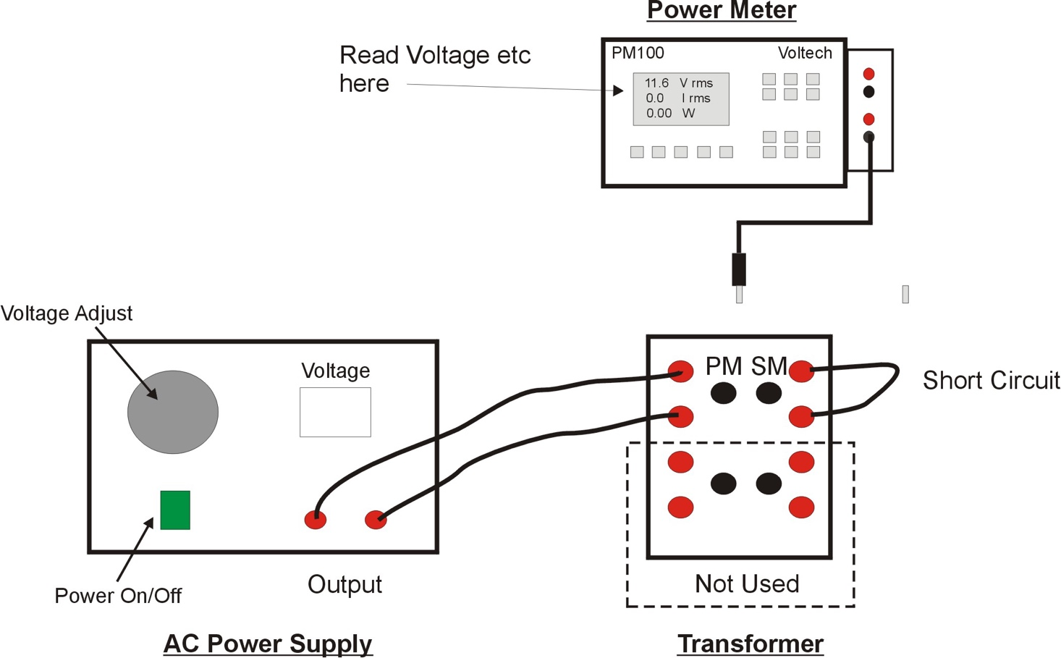

Figure 6: Short Circuit Test Setup

Experimental Procedure (GET DEMONSTRATOR BEFORE TURNING ON):

- Turn off the AC power supply and set the AC voltage to zero.
- Connect a short circuit wire across the transformer Secondary winding as shown on Figure 6.
- Connect the Power Meter to the Secondary monitoring point (SM) on the transformer.
- Turn on the AC power supply and slowly increase the voltage until approximately 3A is measured by the Power Meter in the secondary winding.
- Connect the Power Meter to the Primary monitoring point (PM) on the transformer and record voltage (V_{P}), current (I_{P}) and power (P_{P}).
- Reduce the AC voltage to zero and turn off the AC power supply.

From the test results and above equations determine values for R_{1eq} and X_{1eq}:

Measured Parameter | Value | Units
Primary Voltage (V_{P}) | 2.275 | V
Primary Current (I_{P}) | 1.258 | A
Primary Real Power (P_{P}) | 2.845 | W

Note: If Primary Real Power > Primary Apparent Power then assume Q_{P} = 0 (this is a result of some assumptions in the equivalent circuit which are not valid for a transformer this size)

Calculated Parameter | Value | Units
Primary Apparent Power (S_{P}) | 2.862 | W
Primary Reactive Power (Q_{P}) | 0.311 | W
Winding Resistance (R_{1eq}) | 1.438 | Ω
Leakage Reactance (X_{1eq}) | 0.197 | Ω

From your results fill in the component values of the complete transformer equivalent circuit shown on Figure 7. Also note that the value of Z_{1s’} (secondary load impedance REFERRED TO THE PRIMARY SIDE) is equal to the (turns ratio)² x Secondary Impedance (Zs). Calculate the value for (turns ratio)² based on your measured value for turns ratio and put this value in the box below Z_{1s’} in Figure 7.

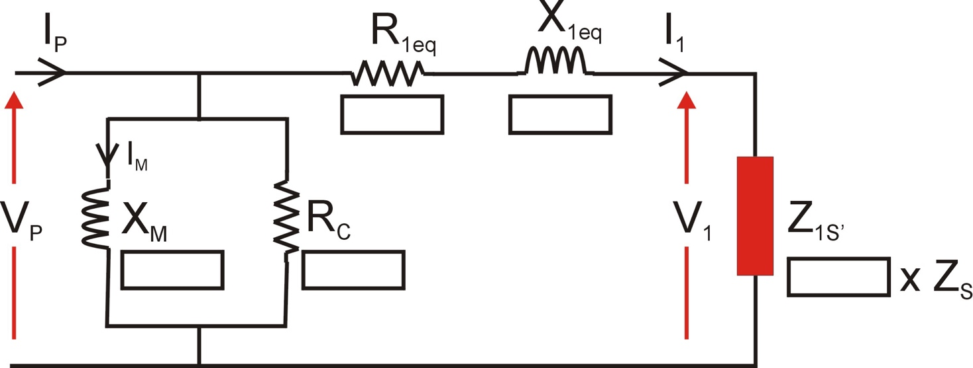

Figure 7: Measured Transformer Equivalent Circuit
Experiment 3: Using the Equivalent Circuit to Predict Transformer Performance

The purpose of the equivalent circuit is to be able to predict transformer performance (output voltage, current, power, efficiency etc) for a given load. You can therefore use your equivalent circuit to calculate transformer performance for a given secondary load impedance and input voltage.

Theory:

Calculate the following parameters using your equivalent circuit for a primary voltage (V_{p}) of 30V and a 6Ω load resistance (Z_{s}) connected across the secondary winding:

- Output Current (I_{S})
- Output Voltage (V_{S})
- Output Power
- Voltage Regulation
- Transformer Copper Loss (W) (hint: associated with R_{1eq})
- Transformer Iron Loss (W) (hint: associated with R_{c})
- Transformer Efficiency

Steps:

- Calculate Z_{1s’} based on (turns ratio)² x 6Ω
- Using the equivalent circuit on Figure 7 calculate I₁ (hint: ignore X_{m} and R_{c} components)
- Using the equivalent circuit on Figure 7 calculate V₁ (hint: V₁ = I₁. Z_{1s’})
- The secondary output voltage and current are derived from I₁ and V₁ through the following relationships (where Np/Ns is the turns ratio):

Parameter | Value | Units
Output Current (I_{S}) | 1.8 | A
Output Voltage (V_{S}) | 10.8 | V
Output Power | 19.44 | W
Voltage Regulation ^{*1} | 3.74 | %
Transformer Copper Loss | 88.2 | mW
Transformer Iron Loss | 0.847 | W
Transformer Efficiency ^{*1} | 95.41 | %

^{*1} See next page for definitions of Voltage Regulation & Efficiency

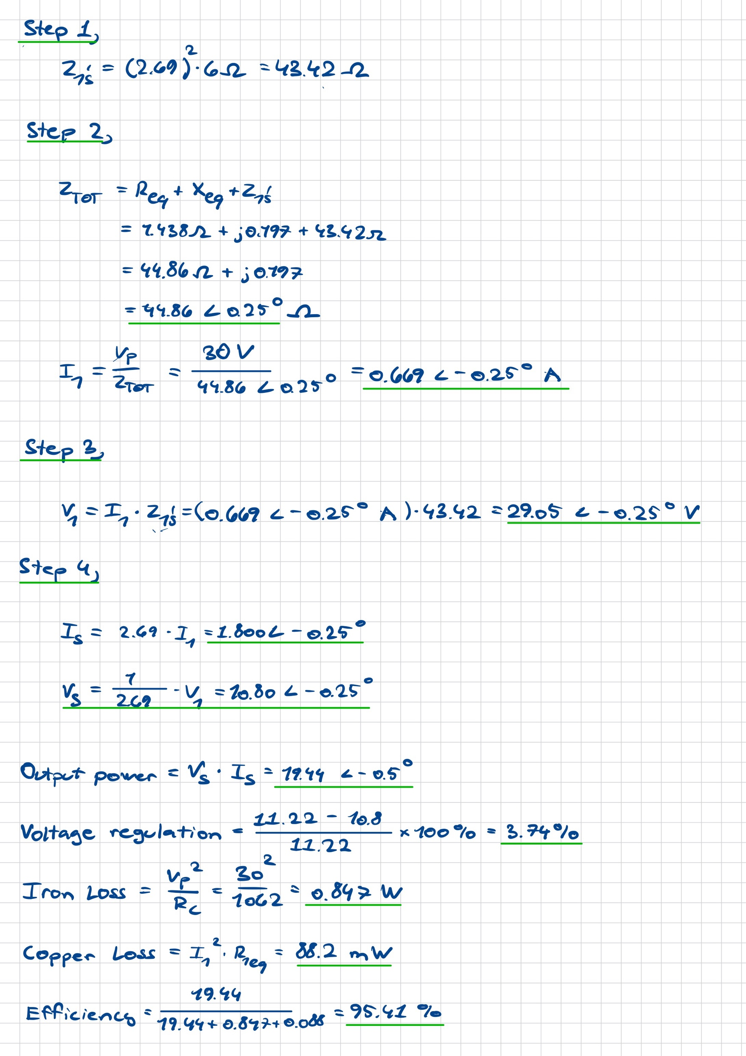

Transformer Regulation & Efficiency

We’ll leave the equivalent circuit for the time being and now look at transformer operation with an actual load connected to the secondary winding. Invariably we want the load to dissipate real power so we will represent this with a simple value of resistance. When we investigate transformer performance we are primarily interested in the following:

- Transformer Voltage Regulation
- Transformer Efficiency

Voltage Regulation is a measure of how well the output voltage (V_{S}) remains constant from no load (open circuit) to full load (maximum I_{S}). It is expressed mathematically as:

Voltage Regulation = V_{SOC} – V_{SL} x 100%
V_{SOC}

where:

V_{SOC} = Open Circuit Secondary Voltage
V_{SL} = Secondary Voltage under load

Given that we want the output voltage to remain as close as possible to the open circuit voltage we therefore want the Regulation value to be as low as possible (typically <5%).

Transformer Efficiency is expressed mathematically using any one of the following equations:

Efficiency = Output Power (W) x 100%
Input Power (W)

Efficiency = Output Power (W) x 100%
Output Power (W) + Losses (W)

Efficiency = Input Power (W) - Losses (W) x 100%
Input Power

The aims of the following series of tests is to measure performance at four different resistive load points, and from the results calculate the Voltage Regulation and Efficiency at each point. The experimental set up is shown on figure 8. The general idea is to measure input and output voltages, currents and powers over the load range for a constant input voltage (V_{P}).

The Resistor Network has four IDENTICAL 24Ω resistors and we can PARALLEL these to give us the following four output impedances:

Load Point | Parallel Resistors | Resistance Z_{S}
1 | 1 | 24Ω
2 | 2 | 12Ω
3 | 3 | 8Ω
4 | 4 | 6Ω

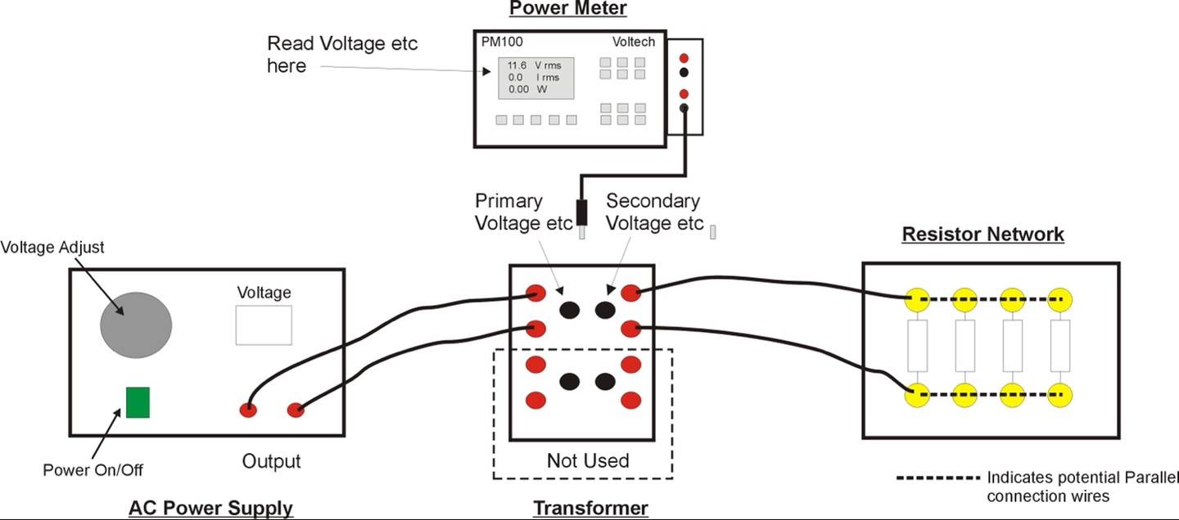

Figure 8: Transformer Regulation & Efficiency Tests

Experimental Procedure:

- Turn off the AC power supply and set the AC voltage to zero.
- Connect a single resistor (Load Point 1) in the Resistor Network to the Secondary winding as shown on Figure 8.
- Connect the Power Meter to the Primary monitoring point (PM) on the transformer.
- Turn on the AC power supply and adjust until approximately 30V is displayed on the Power Meter.
- Measure primary circuit parameters: voltage (V_{P}), current (I_{P}) and real power (P_{P})
- Connect the Power Meter to the secondary monitoring point (SM) on the transformer.
- Measure secondary circuit parameters: voltage (V_{S}), current (I_{S}) and real power (P_{S}).
- Turn off the AC power supply.
- Connect another Resistor Network resistor in parallel (Load Point 2) and repeat test. (note: adjust AC power supply voltage to maintain constant V_{P} as much as possible)
- Repeat for Load Points 3 and 4.
- Repeat for Open Circuit Secondary condition (no resistors connected) but only measure the Secondary voltage (V_{SOC}).
From your test results and associated equations calculate the Voltage Regulation and transformer Efficiency at each of the four load points:

V_{SOC} | 11.17

Load  Point | V_{P} | I_{P} | P_{P} |  | V_{S} | I_{S} | P_{S} |  | Regulation | Efficiency
 | (V) | (A) | (W) |  | (V) | (A) | (W) |  | (%) | (%)
1 | 30.03 | 0.221 | 6.00 |  | 11.09 | 0.459 | 5.10 |  | 0.716 | 85.0
2 | 30.01 | 0.377 | 10.98 |  | 10.98 | 0.906 | 9.94 |  | 1.70 | 90.5
3 | 30.06 | 0.539 | 15.96 |  | 10.87 | 1.348 | 14.68 |  | 2.69 | 92.0
4 | 30.04 | 0.695 | 20.68 |  | 10.76 | 1.766 | 18.96 |  | 3.67 | 91.7

From the results plot Secondary Voltage (V_{S}) and Efficiency against Output Current I_{S} (note using a false zero on the Y axis values is recommended to maximise resolution):

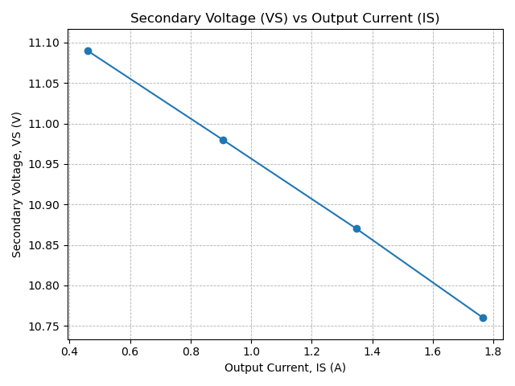

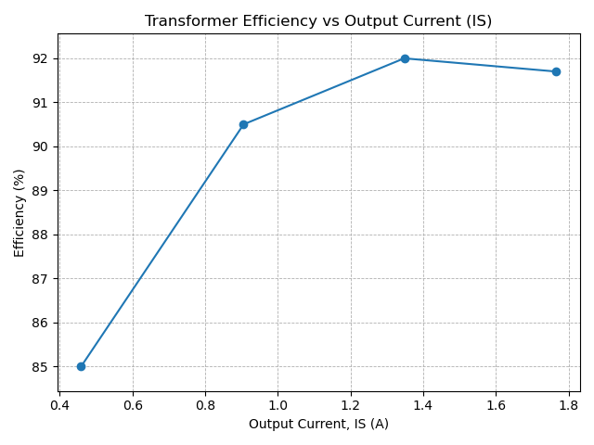

Analysis of Results and Comparison with Theory

Using your results for load point 4 (6Ω load) complete the following table of comparison between your measured results and your theoretical values calculated earlier from your equivalent circuit:

Parameter | Measured | Theory | Units
Output Current (I_{S}) | 1.766 | 1.8 | A
Output Voltage (V_{S}) | 10.76 | 10.8 | V
Output Power | 18.96 | 19.44 | W
Voltage Regulation | 3.49 | 3.74 | %
Transformer Efficiency | 91.68 | 95.41 | %

Experiment 4: Transformer Voltage and Current Limits

The transformer like any other piece of electrical equipment has limitations on the maximum voltage and current which it can operate at.

The current limit is set by the maximum I²R loss which can be dissipated in the transformer windings as this produces heat which in turn causes a temperature rise in the machine windings. If the winding temperature exceeds the maximum temperature of the winding insulation (eg Class F insulation has T_{max} = 155°C) then the insulation will break down and the windings will be permanently damaged.

The voltage limit is set be the maximum flux density (B_{max}) in the transformer core which if exceeded will result in magnetic saturation of the core which in turn leads to increased harmonics (distortion) in the magnetising current. This distorted magnetising current leads to significant increase in the power loss (both copper and iron loss) in the transformer and associated wiring, and can also distort the supply voltage – obviously things to be avoided!

Transformer Current Limit Calculation

A transformer is typically specified with a Voltage limit and a VA limit. This transformer has the following values:

Primary Voltage Limit | 36V
Primary VA Limit | 100VA

Given the relationship between Voltage, Current and Apparent Power, can you suggest a value for the Current Limit:

Primary Current Limit | 2.78 A

A more generic term is to determine the Current Density (A/mm²) limit, where the mm² refers to the cross section of the wire carrying the current. Given that the primary wire has a diameter of 1.12mm calculate the Current Density Limit:

Primary Current Density Limit | 2.82 Amm⁻²

It would be a worthwhile exercise to have a look at some literature to determine if this Current Density Limit is typical for a machine of this type.

Transformer Voltage Limit Experiment

As outlined above if the primary voltage is increased then at some point the magnetic circuit will begin to saturate (see figure 9) resulting in distortion to the magnetising current and increased losses. We can determine the ‘knee point’ of the BH curve by monitoring the TOTAL HARMONIC DISTORTION (THD) of the primary CURRENT using the Voltech Power Meter. Note that the higher the distortion the higher the value for THD (for an ideal sinusoidal waveform THD = 0%)

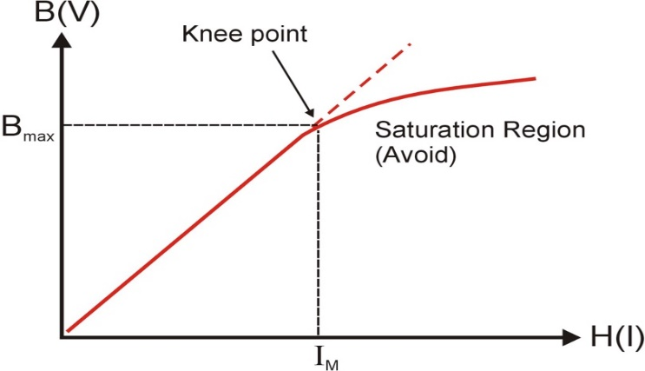

Fig 9: Magnetic core BH Curve

Experimental Procedure:

- Turn off the AC power supply and set the AC voltage to zero.
- Disconnect the load from the secondary winding
- Connect the Power Meter to the Primary monitoring point (PM) on the transformer.
- Ask demonstrator how to set the Voltech Power Meter to measure primary current THD
- Measure the primary current and primary current THD at the following primary voltage values:
Target Primary Voltage (V) | Actual Primary Voltage (V) | Primary Current (A) | Primary Current THD (%)
5 | 5.09 | 0.0169 | 2.24
10 | 10.12 | 0.0294 | 4.21
15 | 15.09 | 0.0424 | 6.64
20 | 20.15 | 0.0574 | 9.39
25 | 25.00 | 0.0754 | 12.84
30 | 30.08 | 0.1022 | 18.38
35 | 35.10 | 0.1473 | 28.14
40 | 40.14 | 0.3018 | 54.29
45 | 45.09 | 1.5420 | 93.47

Plot graphs of Primary Current (X Axis) versus Primary Input Voltage (Y Axis), and Primary Current THD (x axis) versus Primary Input Voltage (y axis). From these determine the primary voltage at the ‘knee point’ of the curve.
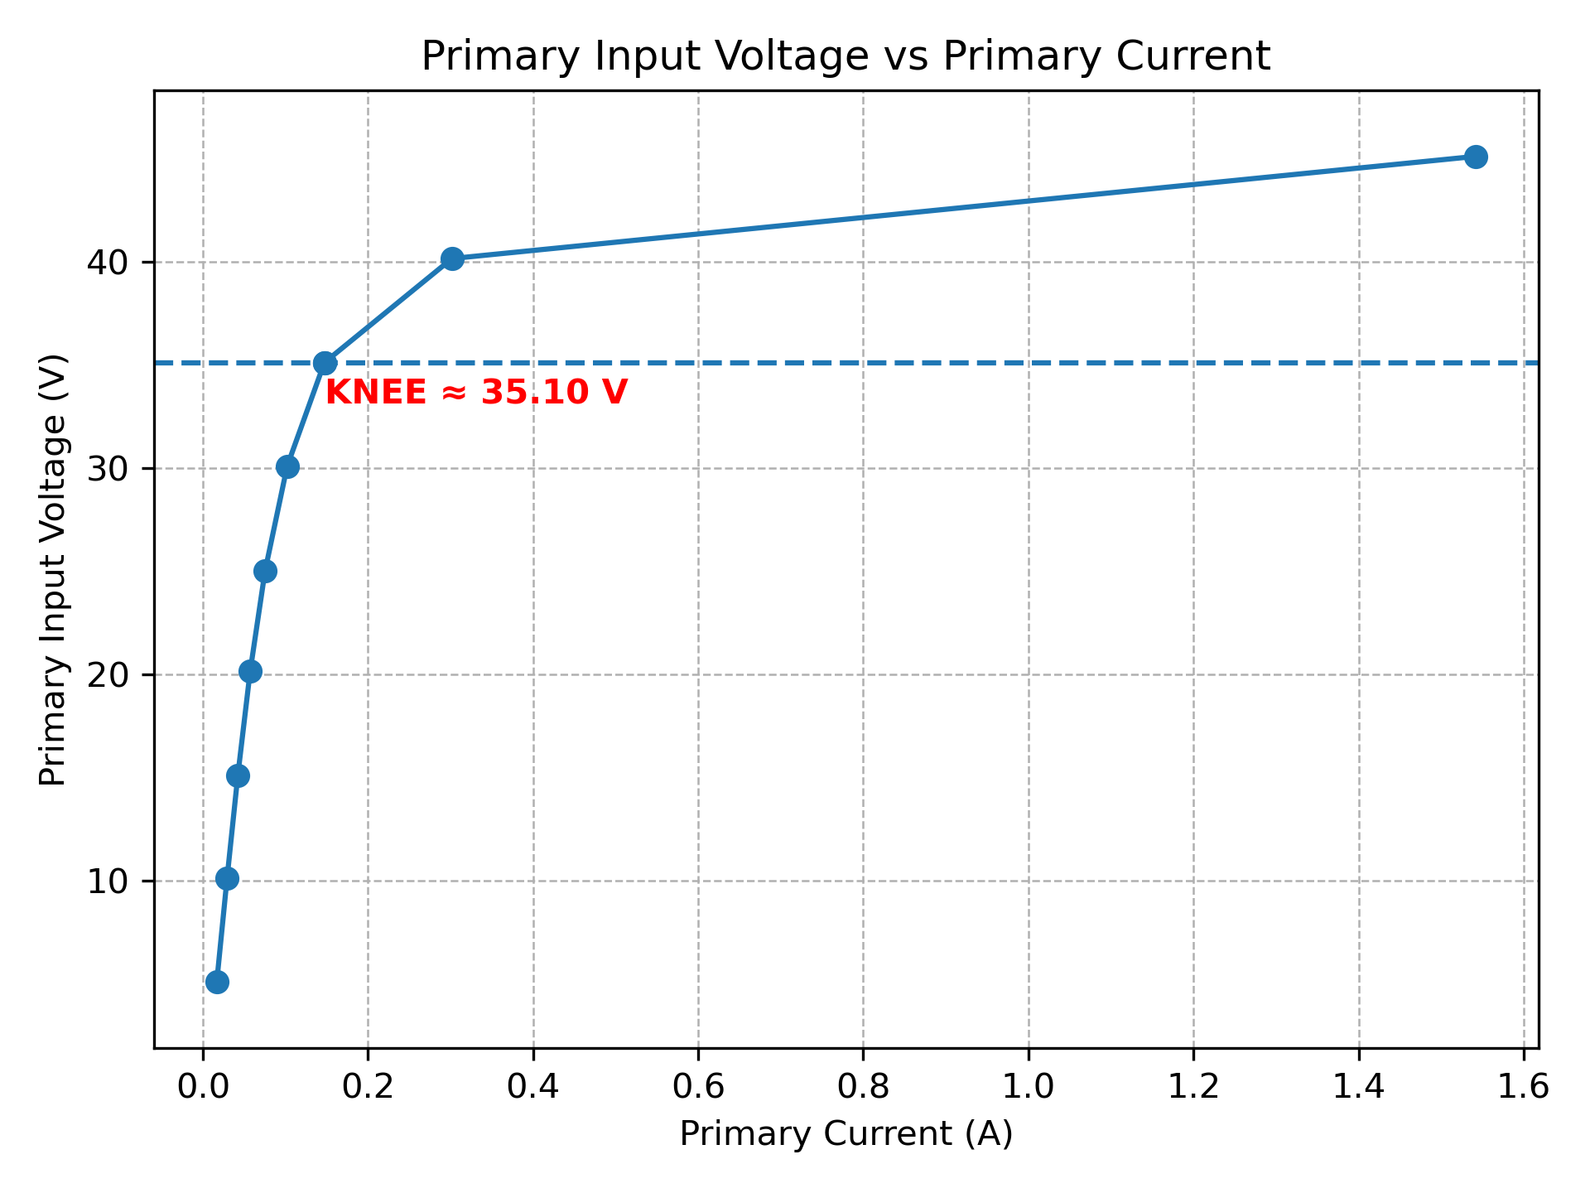
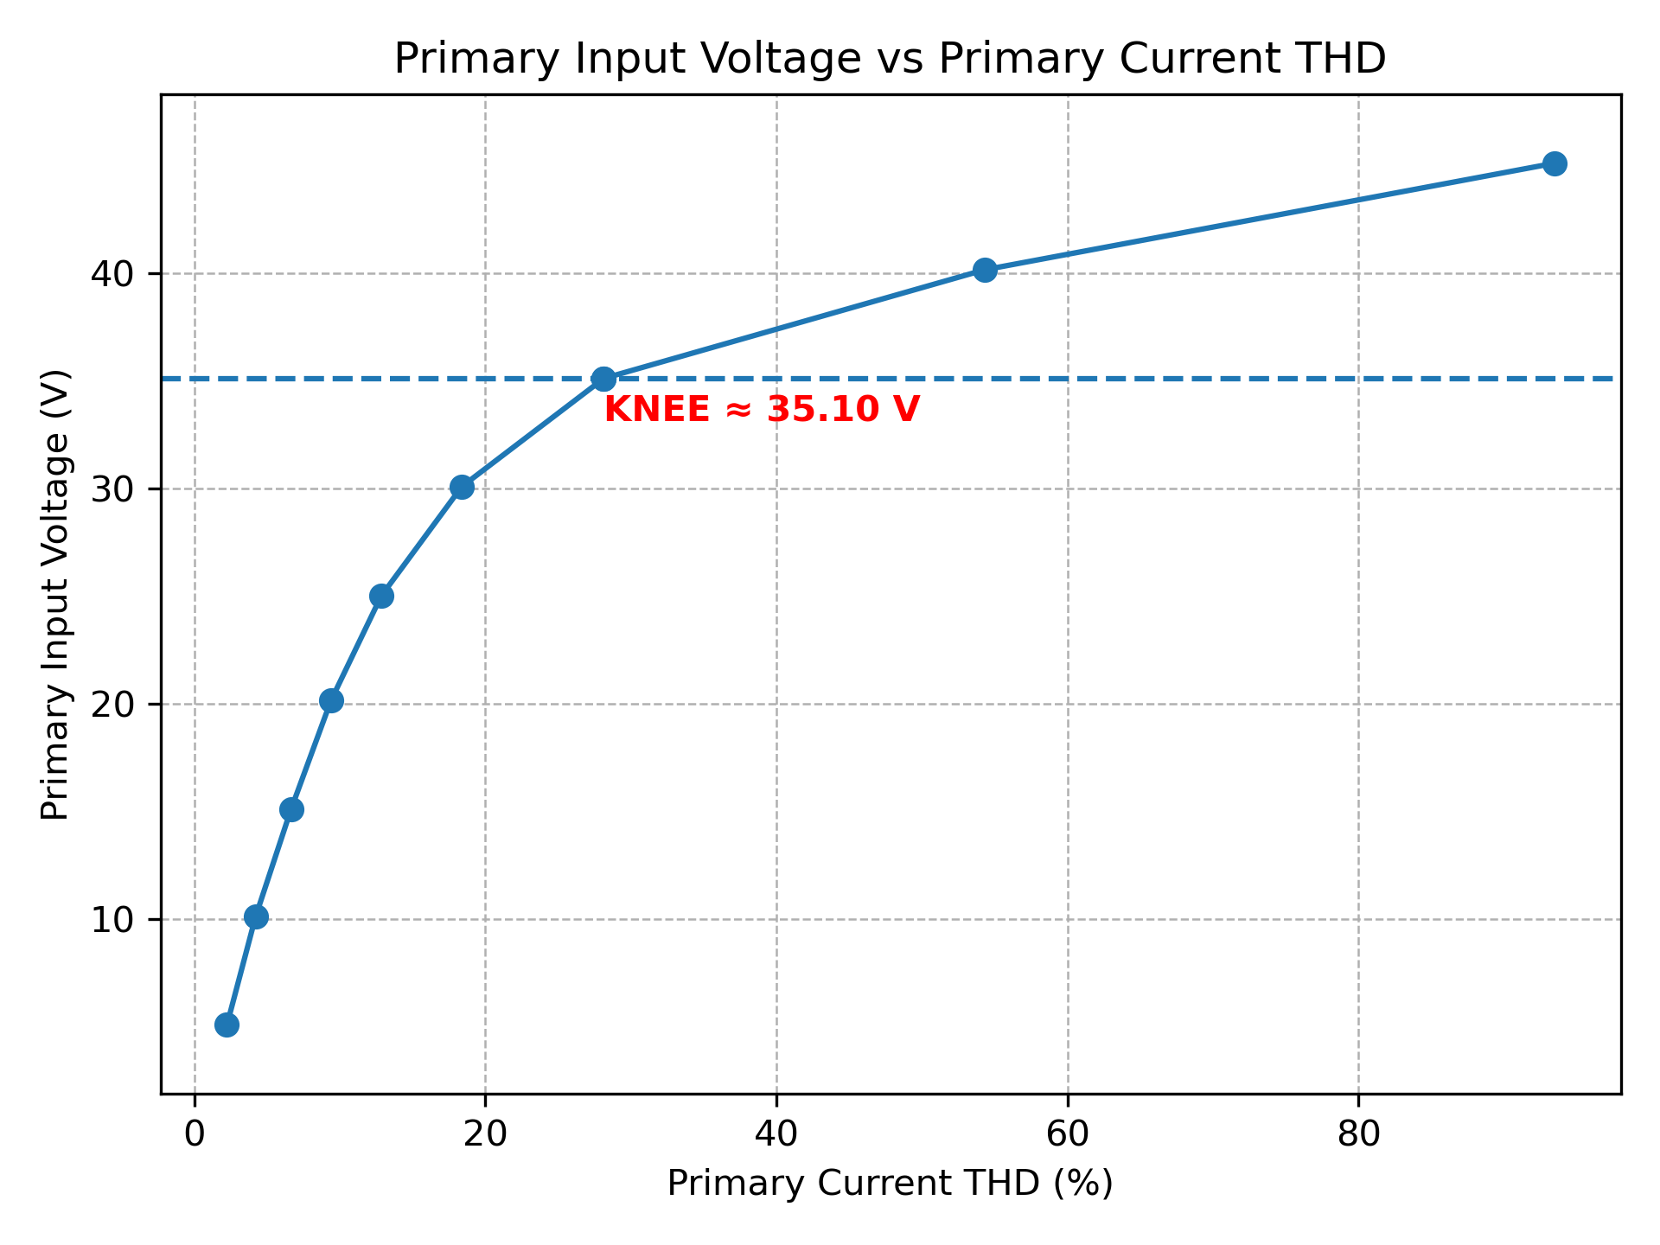

The corresponding Flux Density (Bmax) at this knee point can be calculated from the following relationship and values:
Voltage – Flux Density Relationship | V_{p} = √2.π.f.N_{p}.B.A_{C}  where:  V_{p} = Primary Voltage (V)  f = Supply Frequency (Hz)  N_{p} = Number of primary turns  B = Flux Density (T)  A_{c} = Cross-sectional area of iron core (m²)
f | 50Hz
N_{p} | 170
A_{c} | 640mm²
Vp | 35.10 V

Calculated B_{max} | 1.452 T

Again it would be worthwhile looking up relevant literature to confirm this calculation.

Dr Wenjuan Song
January 2026

